Accredited Ranking SINTA 2
Decree of the Director General of Higher Education, Research and Technology, No. 158/E/KPT/2021
Validity period from Volume 5 Number 2 of 2021 to Volume 10 Number 1 of 2026

Published online on: http://jurnal.iaii.or.id
JURNAL RESTI
(Rekayasa Sistem dan Teknologi Informasi)
 | Vol. 7 No. 1 (2023) x - x | ISSN Media Electronic: 2580-0760

Implementation Of The Prototyping Method On Financial Planning Website Design (Study Case: Sharia My Financial Lifestyle (SMILE))

Ruktin Handayani^{1*}, Mochammad Arief Syahputra²

¹²Informatic, Informatic Faculty, International University of Semen Indonesia, Gresik, Indonesia

¹ ruktin.handayani@uisi.ac.id, ² mochammad.syahputra19@student.uisi.ac.id,

Abstract
Financial planning is crucial in one's life, as it provides clarity and preparedness when faced with unexpected financial needs. SMILE, a financial planning startup, understands the significance of staying competitive in the ever-evolving realm of information technology. To effectively reach their target users, SMILE requires a platform or application that simplifies income and expense tracking, savings management, financial health assessment, financial consultation, and access to the latest finance articles. By leveraging the advancements in information technology, SMILE aims to create a financial planning website that serves as an educational tool, enabling them to connect with users effectively. This research focuses on designing a user-friendly website that educates users about the importance of financial planning and assists SMILE owners in providing solutions for users' financial planning needs. The website is developed using a programming language to meet SMILE users' and testing has been carried out using the user acceptance test which get 100% results and are in accordance with the functionality attributes with a very good scale, then for testing. Additionally, a system usability scale test has been conducted, yielding an average score of 83.05555556, indicating good usability.
Keywords: Financial Planning, Prototyping, User Acceptance Test, System Usability Scale
\
- Introduction
Financial planning is very important in one's life. Without financial planning a person will experience confusion, if he is faced with a problem that requires a person to get emergency funds for unexpected needs (1). It is often found that people are still not used to saving money, and are not used to making a financial plan. Not because they do not have income, but because they are not used to keeping records and making financial plans. Where in the end, whatever the income, the funds are immediately used to meet their needs without making financial records. So that they themselves sometimes forget where all the funds go. And it can be concluded that a person must have financial records, in order to know the amount of income, expenses, and savings for old age (2).
In principle, financial planning should be a tool that helps individuals to efficiently manage their income and expenditure. Financial planning is a process in which one or more individuals seek to achieve their financial goals through the development of a comprehensive financial plan, resulting in a clear and easy guide to financial planning, which can be likened to a blue print that shows the direction of one's financial situation (3). Conducting financial planning has an important function for individuals and families, namely to prepare for the future early on in order to achieve the desired financial goals through structured, organised and wise financial planning (1).
The high number of out-of-school children in Indonesia is strongly influenced by financial planning. Where when someone who is married is less able to manage finances and does not do financial planning for children's education, that is the cause of the high number of out-of-school children in Indonesia. Based on data from the Central Statistics Agency (BPS), in recent years the number of out-of-school children in Indonesia has been quite high, especially at the high school level, which if the situation is not addressed, it will result in an increasing number of children in Indonesia who do not complete their education. The following is a statistical graph regarding the education level of children who are not in school by education level 2019 - 2021 (4).

Figure 1.1 Number of Out-of-School Children by Education Level 2019 - 2021.
(Source: bps.go.id, 2021)

Sharia My Financial Lifestyle (SMILE) is a startup that specialises in financial planning training. To be able to compete and keep up with the rapid development of technology. But SMILE is currently still run manually. So that a platform or application is needed that can cover or reach users which aims to make it easier for SMILE users to record income, expenses, savings, and check financial health, consult financial planning and make it easier for SMILE owners to manage training that will be held, share the latest financial articles. By utilising the current advances in information technology, SMILE needs a financial planning website application that aims to be an educational tool in an effort to reach a wider range of users.
The purpose of this research is to develop the design of a financial planning website-based application to educate users about the importance of financial planning and facilitate SMILE owners in providing user financial planning solutions. With the SMILE website, it is hoped that this website can educate users to be able to carry out individual and family financial planning.

Research Methods
In this research, the method used by the author is the prototyping method. In this section, we will describe in detail the procedures and stages of research that will be carried out by the author. These stages include observation of the object of research, needs analysis, prototype creation, prototype evaluation, application system development, application system testing, and report writing. Some of these stages are presented in the form of a picture which can be seen below.

Observation of Research Objects
The initial stage carried out in this research is to approach SMILE by observing the object of research. In observing the object of research, problem identification is carried out which will be applied in this research. The problem identification process is carried out carefully directly with SMILE and reading the information that has been submitted by SMILE, the author obtained the following information:

- The client wanted the system to look predominantly yellow as there was already a mock-up of the mobile app version.
- The business that SMILE has been running is a business in the financial sector. Where SMILE is here as a financial planning training mentor for users.
- SMILE here also has goals for users where users who take part in training can carry out their financial planning so that they can pay zakat and can save regularly.
- The profit from the SMILE business here is obtained from each user who registers for the training held by SMILE.
- training held by SMILE.
- The current promotion carried out by SMILE is to provide a 50% discount for users who come from academics (Lecturers, Students), but the promotions that have been carried out so far are still using Whatsapp.
- SMILE's target market is users who happen to be the general public.

- The main function of the SMILE website desired by the client is to focus on facilitating users in recording, planning, budgeting, analysing, consulting, and checking financial health through this SMILE website platform, The following is the general flow of the SMILE application system

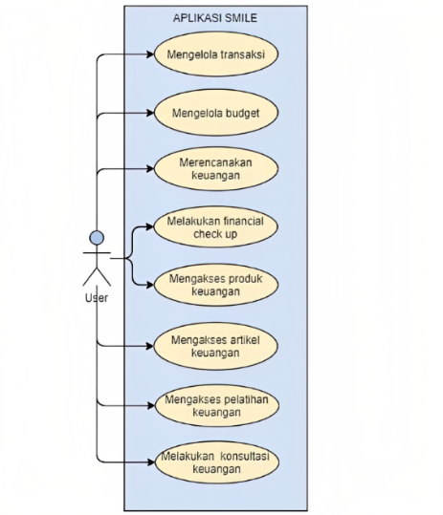
Figure 2.2 SMILE Application Flow in general
Can be seen in Figure 3.2 is an overview of the workflow of the SMILE application where users can manage financial transactions, manage budgets, plan finances, conduct financial check-ups, access financial products, access financial articles, access financial training, conduct financial consultations.

Initial Prototype
After doing a needs analysis. In the next stage, the writer made a prototype which is an initial description of the SMILE website. The prototype was created based on a website needs analysis.
- User Interface

- Homepage Prototype
The following is an initial prototype of the homepage after the user logs in, which provides information about the user's financial records.

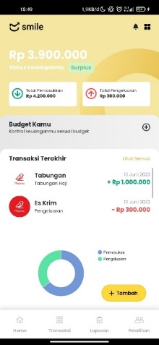 | 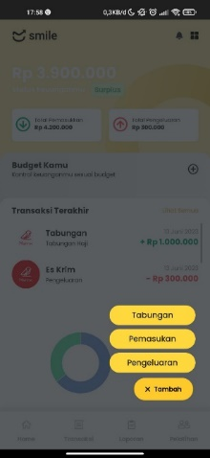

Figure 2.3 Home Page Prototype
- Income Transaction Prototype
The following is an initial prototype of Income transaction page that is a feature that serves to add, edit, and delete income transaction details.

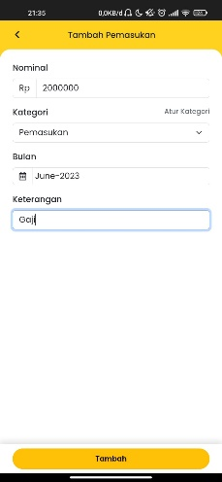 | 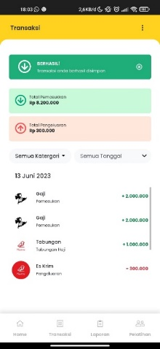
Figure 2.4 Income Transaction Prototype
- Outcome Transaction Prototype
The following is an initial prototype of outcome transaction page that is a feature that serves to add, edit, and delete outcome transaction details.

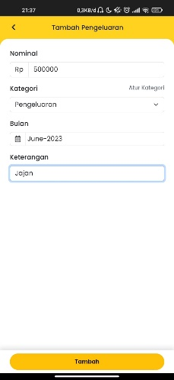 | 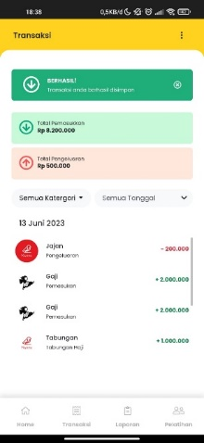
Figure 2.5 Outcome Transaction Prototype
- Financial Plan Prototype
The following is an initial prototype of financial plan page that is a feature that serves to add and know the results of financial plan calculations.

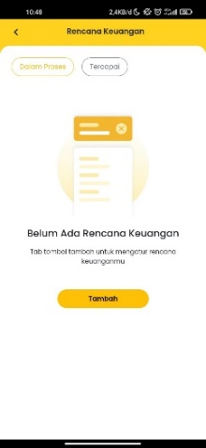 | 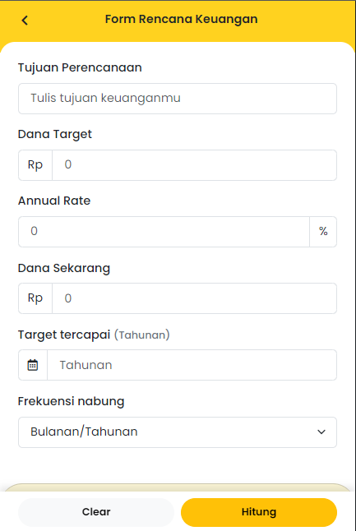
Figure 2.6 Financial Plan Prototype
- Financial Check Up Prototype
The following is an initial prototype of financial check up page that is a feature that can check your financial health.

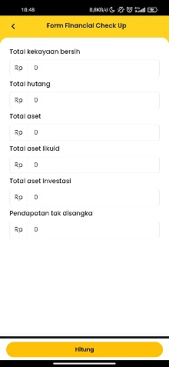 | 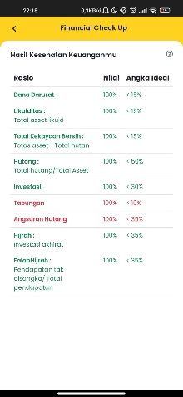
Figure 2.7 Financial Check Up Prototype

Prortotype Evaluation
At this stage after the prototype of the system has been made, the prototype is then evaluated by the client and 3 respondents namely SMILE users whether the prototype that has been made meets the needs desired by the client and user. If the prototype is not in accordance with the needs of the client and the user, the author will again carry out the needs analysis stage from the user and make a prototype.

- Improvements Prototype
- Improvement prototype of currency input form
- First Iteration
Changes the input format by adding a period in each column that uses currency.
(A) (B)
Figure 2.8 Financial Plan Prototype
Figure 2.8 changes to the input format by adding a dot on the Nominal "2000000" in Figure (A) changed to Nominal "2,000,000" in (B) aims to make it easier for users to read when adding transactions
- Improvement prototype of financial plan page
- First Iteration
Change the title of the Annual Rate input to Yield per year.
- (B)
Figure 2.9 changes to the word "Annual Rate" in Figure (A) changed to "Annual yield" in Figure (B) aims to make it easier for users to understand.
- Second Iteration
Changing the date data type to int and changing the input type in the target column is achieved (yearly).
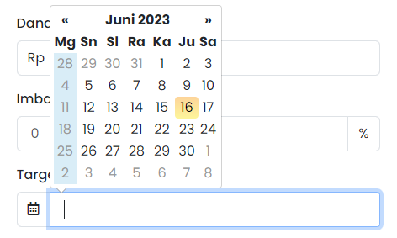 | 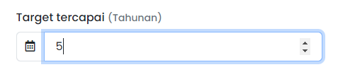
(A) (B)
Figure 2.10 changes to the date data type in Figure (A) to int in Figure (B) and changes to the input type in the target column are achieved (annual)

- Improvement prototype of budget page
- First Iteration
Change the inputs "from month" and "to month" to "from month to month" and add a checkbox "recurring budget".
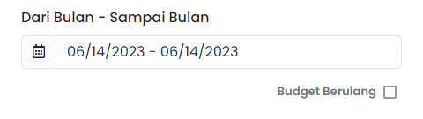
(A) (B)
Figure 2.11 changes the input "from month" and "to month" in Figure (A) to "from month to month" and adds a checkbox "repeating budget" in Figure (B) aims to make it easier for users to add budgets in large quantities at once.

Prototype Testing
At this stage, after the designed application is complete, 1 tests will be carried out to find out whether the application used is appropriate or not, both functionally from the SMILE application and the output produced by the SMILE application. The following are the tests carried out by the author as follows:

- SUS (System Usability Scale) Testing
In this test, the author uses the SUS method to find out whether the application is running without any obstacles based on the test steps. From the explanation above, a questionnaire was compiled that was distributed to SMILE users with answer options:

Tabel 2.1 System Usability Scale

Number | Question
1. | I think that I would like to use this system frequently.
2. | I found the system unnecessarily complex.
3. | I thought the system was easy to use.
4. | I think that I would need the support of a technical person to be able to use this system.
5. | I found the various functions in this system were well integrated.
6. | I thought there was too much inconsistency in this system.
7. | I would imagine that most people would learn to use this system very quickly..
8. | I found the system very cumbersome to use.
9. | I felt very confident using the system.
10. | I needed to learn a lot of things before I could get going with this system.

Score 1 = respondents chose “Strongly disagree”
Score 2 = respondents chose “Disagree”
Score 3 = respondents chose “Doubtful”
Score 4 = respondents chose “Agree”
Score 5 = respondents chose “Strongly agree”

The score calculation formula applies to 1 respondent. For the next calculation, the SUS score of each respondent is sought for its average score by summing up all scores and dividing by the number of respondents. The following is the SUS score calculation formula.
$$\overline{x}= \frac{\sum{x}}{ n}$$
$\overline{x}$ = Average score
$\sum{x}$ = Total SUS Score
n = Number of Respondents

3. Results and Discussions
- Prototype Implementation results

    - User Interface
- Home Page

The following main page can be accessed by users by logging in first using a Google account.

Figure 3.1 Home Page Implementation

In Figure 3.1 is the result of the implementation of the prototype of the main page (Home) that has been made before.

- Entry Transaction Page

Income transaction is a feature that serves to add, edit, and delete income transaction details.

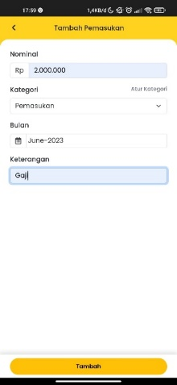

Figure 3.2 Income Transaction Implementation

In Figure 3.2 is the result of the implementation of the prototype of the entry page and also the transaction page which has implemented the results of the evaluation that has been done before.

- Outcome Transaction Page

Expense transaction is a feature that serves to add, edit, and delete outcome transaction details.

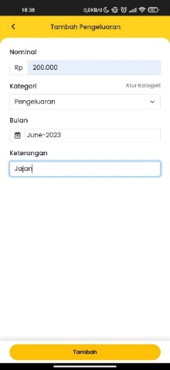

Figure 3.3 Outcome Transaction Implementation

Figure 3.3 is the result of the implementation of the prototype of the expense page and also the transaction page which has implemented the results of the evaluation that has been done before.

- Financial Plan

Financial plan is a feature that serves to add and know the results of financial plan calculations.

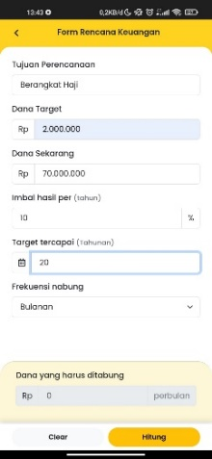

Figure 3.4 Financial Plan

In Figure 3.4 is the result of the implementation of the prototype of the financial plan page where it has implemented the results of the evaluation that has been done before. And also the formula for calculating payments has been installed so that it can be seen how much money the user must collect each month.

- Financial Check Up

Financial Check Up is a feature that can check your financial health.

Figure 3.5 Financial Check Up Page

Figure 3.5 is the result of the implementation of the prototype of the financial check-up page which has implemented the results of the evaluation that has been done before. And there is also a calculation formula that has been provided by SMILE so that it can be seen which parts are not ideal according to SMILE financial calculations.

  - System Testing
Application testing is carried out to test all functions and features in the software whether it is in accordance with the requirements needed. This test uses 2 methods as follows.
- System Usability Scale Testing

    - System Usability Scale (SUS) Testing
The author tests with the system usability scale (SUS) so that it can be seen whether the application system that has been implemented has fulfilled its non-functional needs. This test is carried out by collecting statement points through a questionnaire that has been compiled by the user. The following are the questions in the system usability scale questionnaire:
1. I think that I would like to use this system frequently.
2. I found the system unnecessarily complex.
3. I thought the system was easy to use.
4. I think that I would need the support of a technical person to be able to use this system.
5. I found the various functions in this system were well integrated.
6. I thought there was too much inconsistency in this system.
7. I would imagine that most people would learn to use this system very quickly.
8. I found the system very cumbersome to use.
9. I felt very confident using the system.
10. I needed to learn a lot of things before I could get going with this system.

Description:
Score 1 = respondents chose “Strongly disagree”
Score 2 = respondents chose “Disagree”
Score 3 = respondents chose “Doubtful”
Score 4 = respondents chose “Agree”
Score 5 = respondents chose “Strongly agree”

Tabel 3.1 SUS Testing
Calculated Score |  |  |  |  |  |  |  |  |  |  | Total | Score (Total x 2,5)
No | Q1 | Q2 | Q3 | Q4 | Q5 | Q6 | Q7 | Q8 | Q9 | Q10
1. | 3 | 2 | 4 | 3 | 5 | 2 | 4 | 2 | 5 | 3 | 33 | 82,5
2. | 5 | 5 | 5 | 5 | 5 | 5 | 5 | 5 | 5 | 5 | 50 | 125
3. | 1 | 1 | 3 | 1 | 1 | 1 | 5 | 1 | 3 | 5 | 22 | 55
4. | 5 | 1 | 5 | 3 | 5 | 3 | 5 | 2 | 5 | 3 | 37 | 92,5
5. | 5 | 2 | 5 | 4 | 5 | 1 | 4 | 2 | 4 | 1 | 33 | 82,5
6. | 4 | 2 | 5 | 3 | 5 | 3 | 5 | 3 | 5 | 4 | 39 | 97,5
7. | 3 | 2 | 2 | 2 | 2 | 2 | 2 | 2 | 2 | 2 | 21 | 52,5
8. | 5 | 2 | 5 | 1 | 5 | 3 | 5 | 2 | 5 | 2 | 35 | 87,5
9. | 3 | 3 | 2 | 3 | 2 | 3 | 3 | 3 | 3 | 4 | 29 | 72,5
10. | 5 | 2 | 5 | 3 | 5 | 1 | 5 | 1 | 5 | 3 | 35 | 87,5
11. | 5 | 2 | 5 | 1 | 5 | 2 | 5 | 1 | 5 | 1 | 32 | 80
12. | 5 | 1 | 5 | 4 | 5 | 2 | 3 | 3 | 5 | 2 | 35 | 87,5
13. | 4 | 2 | 5 | 2 | 5 | 2 | 5 | 1 | 5 | 2 | 33 | 82,5
14. | 5 | 1 | 5 | 3 | 4 | 1 | 4 | 2 | 4 | 5 | 34 | 85
15. | 5 | 2 | 4 | 2 | 3 | 2 | 4 | 2 | 4 | 3 | 31 | 77,5
16. | 4 | 2 | 4 | 2 | 5 | 2 | 4 | 2 | 5 | 2 | 32 | 80
17. | 5 | 3 | 4 | 2 | 5 | 2 | 4 | 2 | 4 | 2 | 33 | 82,5
18. | 4 | 1 | 5 | 3 | 5 | 3 | 4 | 2 | 4 | 3 | 34 | 85
Average value |  |  |  |  |  |  |  |  |  |  | 83,05555556

Table 4.2 contains the SUS questionnaire scores that have been collected by the author. The scores of each respondent are summed up and multiplied by 2.5. The result of the multiplication is then divided by the number of respondents to get the average value. After the average value is found, the next step is to find the range of values on the system usability scale method to determine the category from WORST IMAGINABLE to BEST IMAGINABLE.
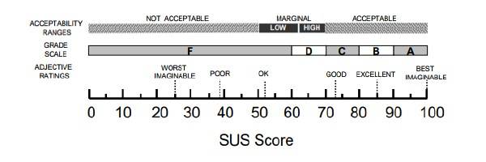

Figure 3.6 SUS Score Assessment Range

The total average of the scores obtained from all respondents is 83.05555556. In the assessment using the SUS Scale, the score is classified as GOOD with grade B. Thus, based on these data, the usability system is given an acceptable or feasible assessment.

4. Conclusion
  - Conclusion
Based on the analysis and discussion that has been described, the authors try to make the following conclusions:
- The use of the Prototyping method can be applied in the design and development of the SMILE website application. The Prototyping model can help application development with a fairly structured and supervised and organised application development documents at each stage.
- In an effort to get the value of application suitability based on client requests and needs, the use of the user acceptance test method can be applied by distributing questionnaires to SMILE and several respondents who are users of the SMILE application later.
- Based on the results of the tests in the results and discussion where the results of the user acceptance test has been carried out which get 100% results and are in accordance with the functionality attributes with a very good scale, then for testing system usability scale test get an average score of 83.05555556, it can be concluded that the SMILE application can be well received by SMILE and SMILE users.

  - Suggestions
Although overall this application is still lacking and not optimal, the author hopes that this application can be realised in the future. As for suggestions for further development, the author provides several suggestions that are expected to be part of the realisation of a maximum application, among others:
- It is necessary to add a payment gateway feature when purchasing products or registering for training so that it will make it easier for SMILE admins or administrators, so that manual payment verification is not required.
- It is necessary to add features such as push notifications when there are new financial products or upcoming trainings so that users can find out information that is useful for financial planning.
- There are components that have not been tested such as security and other application qualities that can be continued in the next research.

Reference
1. Adi Wulandari F, Sutjiati R. Pengaruh Tingkat Kesadaran Masyarakat Dalam Perencanaan Keuangan Keluarga Terhadap Kesejahteraan (Studi pada Warga Komplek BCP, Jatinangor). Jurnal Siasat Bisnis. 2014;18(1).
2. Dian Pratiwi R. Tingkat Kesadaran Masyarakat dalam Perencanaan Keuangan Keluarga Perspektif Ekonomi Islam (Studi pada Masyarakat Kelurahan Cempaka Putih Ciputat). [Jakarta]: Universitas Islam Negeri Syarif Hidayatullah; 2010.
3. Andi Chaerunnisah Heriyanto A. Jurnal Bisnis dan Akuntansi Unsurya Jurnal Bisnis dan Akuntansi Unsurya. 2022;7(2):73–88.
4. Rio Rita M, Santoso B. Rita dan Santoso: literasi Keuangan dan Perencanaan Keuangan pada Dana Pendidikan…. Jurnal Ekonomi. 2015;XX(02):212–27.

- Akbar, A. (2007) Rich Game : Cara Kaya Dengan Investasi, Pengetahuan Dan Simulasi Permainan Gaya Orang Kaya Untuk Mereka Yang Ingin Menjadi Kaya. Jakarta: Rabka. Available at: http://perpustakaan.thamrin.ac.id/index.php?p=show_detail&id=10423&keywords=.
- Elvira Unola, N.L. (2014) ‘Analisa Hubungan Faktor Demografi Dengan Perencanaan Dana Pendidikan dan Dana Pensiun Pada Masyarakat Ambon’, Finesta, Vol 2, No. Available at: https://publication.petra.ac.id/index.php/manajemen-keuangan/article/view/2429.
- Financial Planning Standards Board (2021) Perencanaan Keuangan Untuk Masa Depan Anda dan Keluarga., FPSB. Available at: https://www.fpsbindonesia.org/publik-media (Accessed: 3 October 2022).
- Huber, S., Demetz, L. and Felderer, M. (2022) ‘A comparative study on the energy consumption of Progressive Web Apps’, Information Systems, 108, p. 102017. Available at: https://doi.org/10.1016/j.is.2022.102017.
- ISO (International Standard) (2018) Ergonomics of human-system interaction — Part 11:Usability: Definitions and concepts. Available at: www.iso.org.
- Josi, A. et al. (2017) ‘STMIK-MUSIRAWAS LUBUKLINGGAU 50 Penerapan Metode Prototiping Dalam Pembangunan Website Desa (STUDI KASUS DESA SUGIHAN KECAMATAN RAMBANG)’, JTI, 9(1).
- Keuangan, D.L. dan I. (2017) Strategi Nasional Literasi Keuangan Indonesia, Otoritas Jasa Keuangan. Available at: https://ojk.go.id/id/berita-dan-kegiatan/publikasi/Pages/Strategi-Nasional-Literasi-Keuangan-Indonesia-2021-2025.aspx (Accessed: 15 October 2022).
- Mohd, C.K.N.C.K. and Shahbodin, F. (2015) ‘Personalized Learning Environment: Alpha Testing, Beta Testing & User Acceptance Test’, Procedia - Social and Behavioral Sciences, 195, pp. 837–843. Available at: https://doi.org/10.1016/j.sbspro.2015.06.319.
- Muddin, S., Tehuayo, H. and Iksan, F. (2021) ‘Penerapan Teknologi Progressive Web Apps (PWA) Pada Sistem Informasi Sma Negeri 7 Buru Selatan’, Jurnal Teknologi dan Komputer (JTEK), 1(01), pp. 16–23. Available at: https://doi.org/10.56923/jtek.v1i01.48.
- OJK (Otoritas Jasa Keuangan) (2014) PERENCANAANK E U A N G A NIBU RUMAH TANGGA.
- Siswidiyanto, S. et al. (2020) ‘Sistem Informasi Penyewaan Rumah Kontrakan Berbasis Web Dengan Menggunakan Metode Prototype’, Jurnal Interkom: Jurnal Publikasi Ilmiah Bidang Teknologi Informasi dan Komunikasi, 15(1), pp. 18–25. Available at: https://doi.org/10.35969/interkom.v15i1.64.
- Suhaimah, A., Triayudi, A. and Handayani, E. (2021) ‘Pengembangan Perpustakaan Online Berbasis Web Menggunakan Metode Prototyping (Studi Kasus Universitas Nasional).’, JTIK (Jurnal Teknologi Informasi dan Komunikasi), 5(1).
- Supriatna, R. (2018) Implementasi Dan User Acceptance Test (Uat) Terhadap Aplikasi E-Learning Pada Madrasah Aliyah Negeri (Man) 3 Kota Banda Aceh.
- Yoko, P., Adwiya, R. and Nugraha, W. (2019) ‘Penerapan Metode Prototype dalam Perancangan Aplikasi SIPINJAM Berbasis Website pada Credit Union Canaga Antutn’, JURNAL ILMIAH MERPATI, VOL. 7.
- Yushita, A. (2017) ‘Pentingnya Literasi Keuangan Bagi Pengelolaan Keuangan Pribadi’, JURNAL NOMINAL, 6(1).

